* Microservices is fundamental architecture for cloud native application.
* 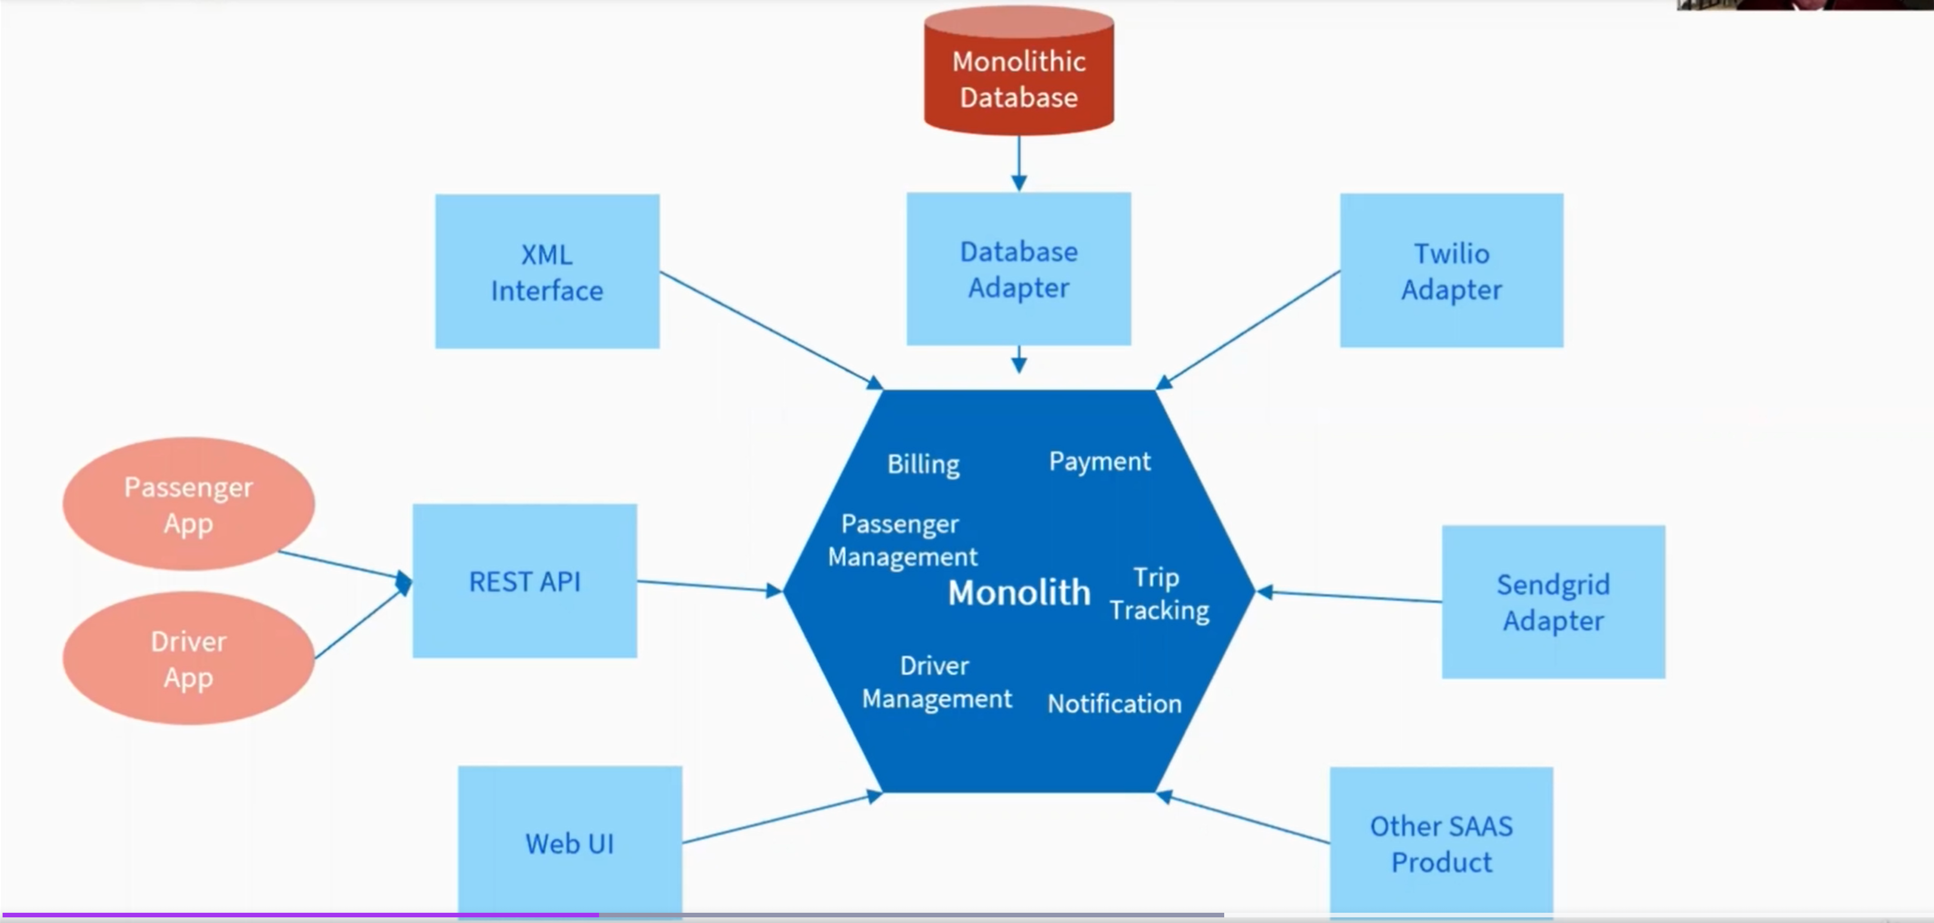
* All module, process or service running under same server and inside same application called monolith.